**Lab Number: 03**

**To learn RMI basics: Generate the stubs and**

**skeletons and run client and server**

1. **Create RMI program in which server performs basic arithmetic operations.**

Interface

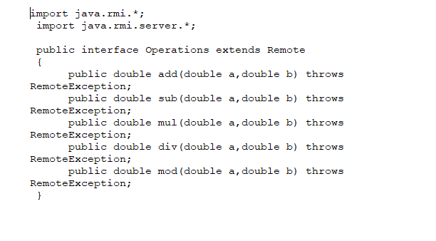

Remote Class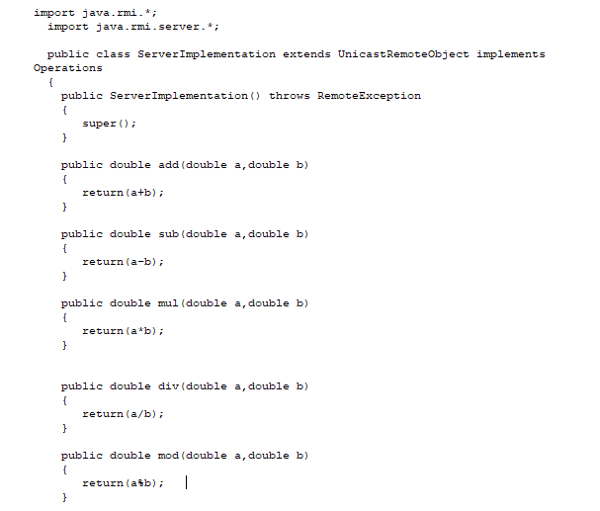

Server Main Class

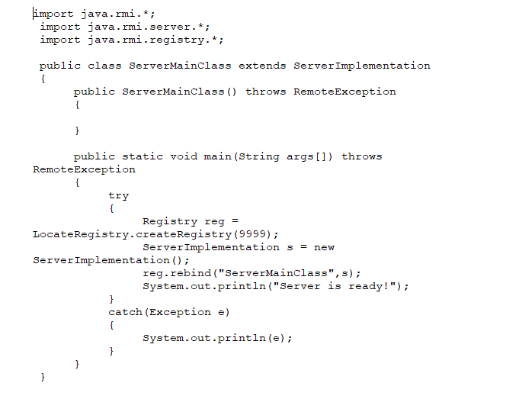

Client Main Class

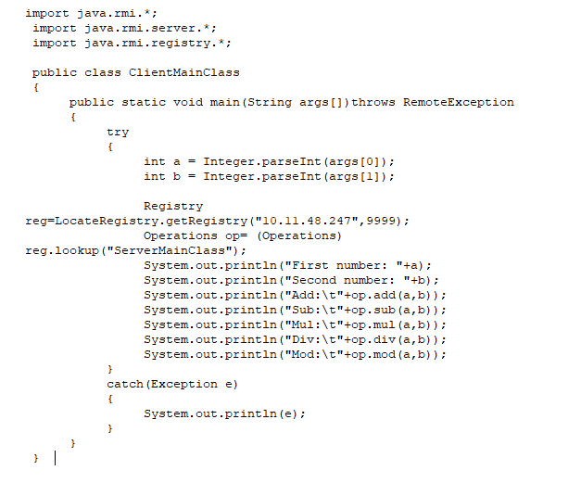

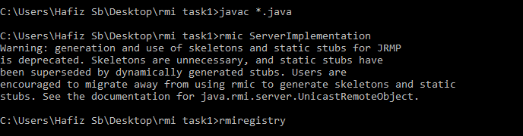

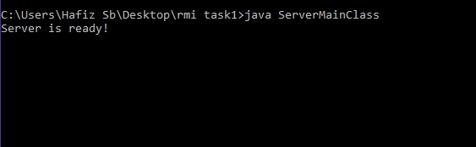

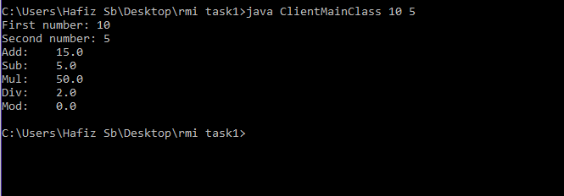

1. **Create RMI program in which server sorts the numbers in ascending order.**

Interface

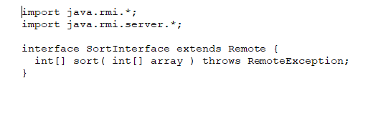

Remote Class

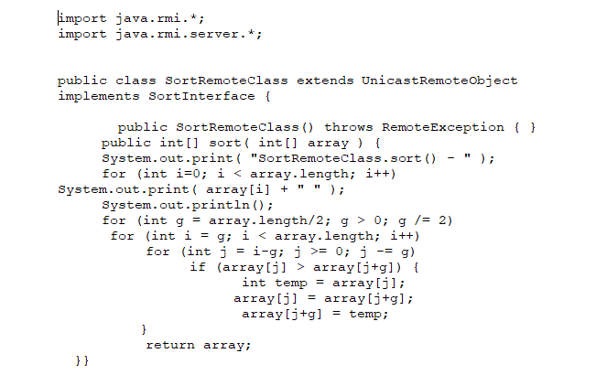

Server Main Class

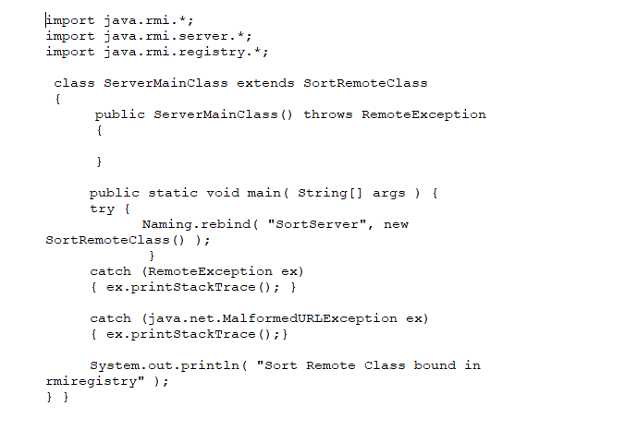

**Client Main Class**